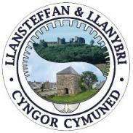
CYNGOR CYMUNED LLANSTEFFAN A LLANYBRI
LLANSTEFFAN AND LLANYBRI COMMUNITY COUNCIL

Minutes of the Llansteffan and Llanybri Community Council Ordinary Meeting held on Monday 15th June 2026 at 7pm

Item # | Item
1. | Present and Apologies  Present: Cllr Rhian Worrell (Chair), Cllr Ian Roberts, Cllr Sue Ball, Cllr Daff Davies and Cllr Tina Roberts  Apologies: Cllr Darren Sainty (Vice Chair) - Work commitments.  Public Participation: One request from the public (Liz Dutch)
2. | Declarations of Interest and Dispensations  Cllr RW and SB declared an interest in relation to Item 13 - they are members of the Llansteffan Pride Committee. The Cllrs will extract from the meeting at Item 13(e).  The Chair reminded Councillors to declare any interest that arises during the meeting if it had not been anticipated beforehand.
3. | Chair’s Announcements  Welcome to everyone that has joined the meeting. No new Chair announcements.
4. | To receive and confirm the accuracy of the minutes of the Ordinary Meeting and AGM held on 18th May 2026  Cllrs reviewed the minutes for accuracy. The minutes of the previous ordinary meeting were proposed by Cllr SB and seconded by Cllr DD.
5. | Matters Arising  No new matters arising from the minutes. The Action Log and Agenda contain the ongoing matters for discussion for the Community Council.
6. | Public Participation (15 mins) via written questions and statements to the Clerk - Agenda items only  Questions received from Liz Dutch for public participation:  “Firstly, please can the clerk clarify the Local Government Act rules and key requirements for publishing the ‘Notice of Vacancy’ following the resignation of a local councillor.”  “Secondly, please can the council explain precisely why (i) there have been only 5 seats filled out of 10 on LLCC for many months (more recently 6 out of 10); and (ii) ‘Notices of Vacancy’ have not been published on village notice boards as soon as practicable after the resignation of a member.”  Cllrs discussed the queries. Cllr TR explained that Carmarthenshire County Council were contacted on a number of occasions, the vacancies were advertised correctly and CCC Electoral Services were content for LLCC to leave the vacancy adverts open ended until the vacancies were filled.  The Chair and Councillors felt it would not be helpful to revisit the difficulties experienced by the Community Council, including the loss of members over the past 12 to 18 months. The Council's preference is to focus on moving forward constructively.  Clerk BC has shared with Liz and Cllrs a breakdown of the Local Government Act rules and key requirements for publishing the ‘Notice of Vacancy’ following the resignation of a local councillor.
7. | Co-option of new member: process and potential candidate  Cllrs approved the recent application for co-option to the Community Council and welcomed Andrew Cooper (Cllr AC) to the Community Council.  Cllr AC signed the Acceptance Notice of Office (read out by the chair on behalf of Cllr AC). ACTION: The Clerk will inform Electoral Services of the appointment to the Community Council.
8. | Review of Action Log  The clerk reviewed the Action Log with Cllrs. The Action Log is available on request from the clerk (supporting documents).  Castle Lights - Chair RW requested it be noted in the minutes that full responsibility and management of the Castle lights now sit with Llansteffan Tourist Association as mutually agreed. Cllr RW explained that Cadw will need to be informed accordingly. ACTION Chair RW to share correspondence with Clerk to follow up on this action.  Cllr Surgeries - Cllr Surgeries at the Hwb and Coffee Mornings (with Llansteffan Memorial Hall and Llanybri Community Hall respectively). Responses from both Hall Committees below.  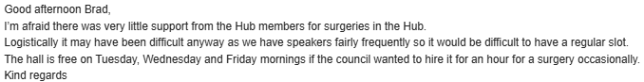  Following on from the unsuccessful attempt to set up Cllr surgeries, Cllrs discussed the need to invite direct public participation back into Community Council meetings. Cllr DD proposed that Public Participation be reviewed in July. Cllrs voted (agreed by Cllrs SB, AC and RW). Not agreed by Cllrs IR and TR. Majority voted to review the Public Participation Standing Orders in the July meeting.  Post Box in Llanybri - The post box will be installed in Llanybri on or around the 20^{th of} June 2026. Cllr TR wanted to express the fact that the new location of the post box has been dictated by the Post Office and related to H&S of postal workers. It was not the choice of the Community Council. ACTION Chair Cllr RW to add to social media.  BT Telephone Box - Telephone Box at the South end of the Village Green in Llansteffan can be purchased for £1 (permission granted by BT). Proposed by Chair Cllr RW and Seconded by Cllr SB. ACTION Clerk to electrically sign a contract (telephone box). Clerk to follow up with first responders to support the improvements to the local defibrillators.
9. | Community Issues  Notice Boards: Replacement of Llansteffan and Llanybri notice boards (2026/27 budget)  ACTION Cllr TR will look at the notice board in Llanybri. The notice board is only 3 years old and should be easily maintained.  The notice board in Llansteffan is in a poor state of repair, notices / papers get wet inside.  ACTION Cllr RW will consult with the Memorial Hall Committee before any decisions to replace the LLCC notice board are made. After consultation the notice board improvement plan will be costed up for the 2027/28 budget setting in January 2027. The clerk will review and add to the precept / budget meeting in Q3 accordingly.  Notice boards to remain on the agenda.  Sea pollution: Burst main sewage running into the River Towy; NRW water testing update at Llansteffan  The point of contact to support sea pollution is Cllr Darren Sainty. ACTION Chair Cllr RW to contact WI to find out who the point of contact is for the volunteer testing initiative to support the agenda item moving forward. Sea pollution to remain on the agenda.  Llansteffan Village Green – Street Lighting Grant Application  Clerk has emailed Arwel W Price (Carmarthenshire County Council) requesting next steps on street lighting grant application. Email received from Arwel (please see below).  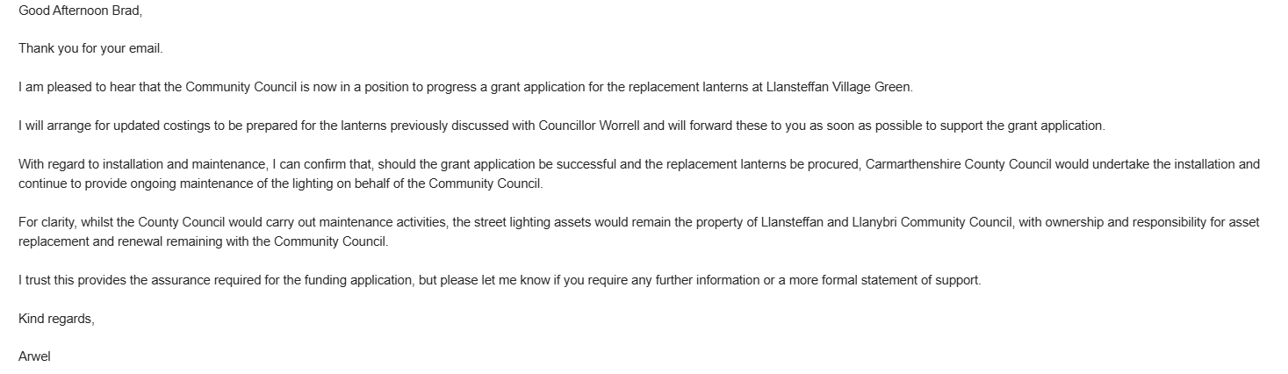  Once Arwel has responded with information needed, the Clerk will ask the County Councillors (Cty Cllr C Jones and Cty Cllr P Hughes) and CCC Conservation Officer for letters of support. Chair Cllr RW to complete the grant application, once all the above has been received.  Street Lighting Grant to remain on the agenda.  Sports Club Lease  The Community Council have emailed Carmarthenshire County Council to explore options around the upcoming lease arrangements. Please see the email below.  The Sports Club have emailed the County Council asking the same question as the Community Council.  Carmarthenshire County Council have passed to officer Emily Hughes to support.  Dear Stephen,  I am writing on behalf of Llansteffan and Llanybri Community Council regarding the lease arrangement for the Morfa.  Under the current arrangement, the Community Council acts as an intermediary in the lease between the County Council and the Sports Club. We would like to explore whether it would be possible for Carmarthenshire County Council to lease the Morfa directly to the Sports Club, thereby removing the Community Council as the middle party.  Could you advise whether such an arrangement would be feasible, and what steps would be involved? We would be happy to discuss this further at your convenience.  Thank you for your assistance.  Kind regards,  Llansteffan and Llanybri Community Council  Sports Club Lease to remain on the agenda.
10. | Beach Front and Car Parks  - Cockle Season: Update from the joint Community Council group (to be known as The Three Rivers Community Organisation comprising of Llansteffan and Llanybri, St Ishmael, Laugharne Township) and Carmarthenshire County Council stance / support.  Cockle season is due to start in mid-July. Cllr TR (in her role as Temp Clerk to Laugharne Township Community Council), requested a date for attendance of LLCC Cllrs to the next meeting of the Joint Community Council group prior to the Fisheries Stakeholder meeting. Cllrs agreed on Monday 22.06.2026.  Cllr AC inquired as to the purpose of the meeting / desired outcome of the Community Council group. Cllr TR gave an overview of the issues relating to cockling across the three community councils and explained the purpose of the group. The main aim is to work constructively with all key stakeholders towards a shared understanding. The group is keen to stress that no one wishes to prevent cocklers from coming to our communities; rather, the hope is to agree some simple, reasonable guidelines so that everyone can work together and our communities are treated with the respect they deserve.  Cllr TR explained the Community Council has a set of rules for Llansteffan Community Council.  Chair Cllr RW explained the difficult access issues relating to the LLCC owned land at the Northern end of the Village Green. Cllr RW spoke about the fact that there are two lawful access routes that could be used by the cocklers, but each presents serious issues to the community.  Cllr AC declared a personal interest at this point due to the fact that he has relatives living on Church Road.  Cllr AC would be happy to join the meeting of the joint Community Councils group. He emphasised that group must be clear about what it wants from the stakeholder meeting. Cllrs agreed to meet Monday 22.06.2026 (the 3 rivers) to prepare for the stakeholder group.  Cockle Season to remain on the agenda.  - Anti-social behaviour at Llansteffan beach front. Correspondence with QEH Secondary School.  Chair RW confirmed that students from QEH Secondary School would be carrying out litter picks in Llansteffan on 26 June and 1 July as part of the Welsh Baccalaureate Community Challenge. There will be approx. 100 pupils at each event. Extremely positive news. ACTION Chair RW will follow up with other local schools.
11. | Highways / Traffic  - Road landslide. ACTION Cllr IR to take photographs of the road landslide. Clerk to write to Carmarthenshire CC highways following receipt of photos.
12. | Planning  - PL/10865 - Proposed agricultural/rural enterprise storage building - Glyndwr, Old School Road, Llansteffan, Carmarthen, SA33 5LG  As per the CCC Planning Portal Built Heritage have informed CCC Planning that they require more time to consider the application and are unable to provide a formal response before the consultation deadline. Chair RW explained the Community Council may be required to wait for the Built Heritage Consultation response before making a comment on the application. Cllr RW noted that to date there were no community objections on the Planning Portal.  Cllr TR explained there could be issues with a requested extension to the planning application. Cllr TR proposed to approve the planning application as long as the further information requested by Built Heritage is complied with. Cllrs were happy with approving the application.  ACTION: Clerk to write to Carmarthenshire Community Council to approve planning application (no issues).  - Member of the public query regarding submission of planning applications; PL/10310 & PL/10804  Query received from a member of the public regarding planning applications PL/10310 & PL/10804.  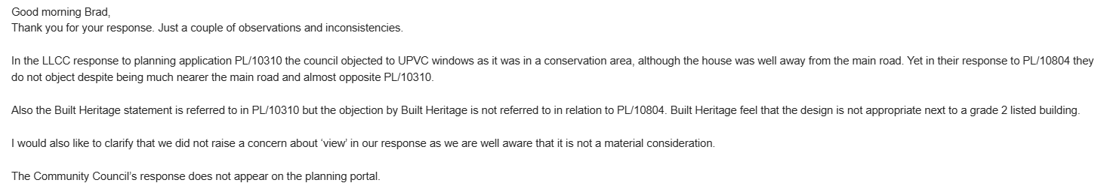  Chair Cllr RW responded to each of the points raised in the correspondence above. On PL/10804, she explained that the Build Heritage response could not have been taken into account, as it was dated 18 May, the day of the Community Council's meeting, and had therefore not yet been seen by Councillors. She then explained the differences between PL/10310 and PL/10804 in relation to plastic windows and clarified the responses the Community Council had made to both applications.  Cllr AC discussed the wording being used when responding to planning applications, and suggested wording such as “we have no objections” or “we have no objections subject to X, Y, Z” would be more appropriate. Cllrs happy to support this suggestion.
13. | Finance / Governance  - 2026/27 Payments and Receipts  Payment and receipts documents for 2026/27 are available on request. Payments and receipts proposed by Chair Cllr RW and seconded by Cllr TR.  Payments approved by Cllrs:  Pride Committee Grant / Donation request: £400.00 (see Item 13e)  Zurich Insurance: £804.09  Sports Club donation: £1,000.00 (see Item 14)  - 2025/26 Audit Wales Submission / Annual Statement of Accounts  Cllrs reviewed the 2025/26 Audit Wales Submission / Annual Statement of Accounts. Cllrs happy with the basic audit submission and internal audit documents.  ACTION Clerk to submit the 2025/26 Audit Wales Submission / Annual Statement of Accounts to Audit Wales prior to the deadline (30.06.2026).  - 2025/26 Annual Report  Cllrs discussed the DRAFT annual report. ACTION Chair RW requested Cllrs to respond to the Clerk by Monday 22.06.2026 with any updates / amendments to the report before publishing on the website. Cllr AC will not be making comments on the report as he has only just joined LLCC.  - Asset Register (community benches and updated Bench Policy)  Cllr TR explained the bench policy and how it related to Llanybri, as per the policy the approach is different in Llansteffan, benches are managed by Carmarthenshire Community Council. The Community Councils bench policy is available on request.  - Grant applications: Pride Committee (resubmission with bank account or via Village Hall Committee)  Cllr RW and SB left the meeting.  Cllr TR confirmed the community council to be quorate at 4 Cllrs to discuss the grant application and approve / decline the proposal.  The Cllrs discussed the revised grant submission. The Clerk read out and explained the amendments to the application. Proposed Cllr TR and seconded IR (approved by Cllr DD). Cllr AC abstained.  Cllr RW and SB returned to the meeting.  Cllr AC asked about the grant application process / policy. Chair Cllr RW recommended reviewing the grant policy in the next Community Council meeting. ACTION to add Grant Policy to the Finance agenda item in the July meeting  - Ordinary meeting venues for 2026/27 (rotation between Llansteffan and Llanybri)  Cllr TR suggested that LLCC might consider holding the majority, if not all, of its meetings in Llanybri, noting the notable difference between the funds held by Llansteffan Hall and those held by Llanybri Hall. Councillors welcomed the discussion and explored the idea of holding more meetings in Llanybri than in Llansteffan as a way of helping to support the finances of Llanybri Community Hall. While there was not full agreement on making this change, the conversation was a positive one. Cllr TR helpfully proposed an alternative: adjusting the seasonal pattern of meetings between Llanybri and Llansteffan, so that Llanybri Hall is used during the summer months and the Hall Committee is spared the cost of heating the hall for the Community Council's summer meetings. Councillors were pleased to support this constructive compromise.  DRAFT 2026/27 meeting months below:  Llanybri: May, July, September, October, February and March  Llansteffan: April, June, November, December and January  ACTION: Clerk to book hall dates with Hall Committees
14. | Correspondence of Note  Morfa Park (bark / chippings for slide).  Chair Cllr RW has removed the trip hazard from the ground surface at bottom of the slide the Morfa Play Park. As Mr Ed Davies was present at the meeting Cllrs asked him for a quote to remove all the offending plastic and make good the surface for new bark chipping around the slide.  Sports Club letters (Fiesta Committee and annual maintenance fee) and container consent.  Cllrs are happy to approve the Fiesta Committee, approve the annual maintenance fee of £1,000 and give consent for the replacement container.  Group Stroll Along Survey of the Dunes  Chair Cllr RW confirmed the group identified 54 species (flora and fauna). Unfortunately, it was horrible weather so attendance was understandably low, but the group will re-schedule and re-advertise for another survey in August 2026.  County Cllr update  Questions asked by the Community Council:  County Cllr update / response:
15. | Matters for information  Cllr SB gave a positive update of the upcoming Pride festival. The event is open to all, the aim of the day is for it to be a fun, joyful, inclusive day. All monies raised will go to Children’s Leukaemia Society (Wales).  Cllr AC discussed creating a gov.uk / llyw.cymru website / email address for Cllrs. This will be fully explored by the Clerk in due course.

