
CYNGOR CYMUNED LLANSTEFFAN A LLANYBRI
LLANSTEFFAN AND LLANYBRI COMMUNITY COUNCIL

An Ordinary Meeting of the Council was held in Llanybri Community Hall on MONDAY 20th JULY 2026 at 7.00pm.

Item # | Item
1 | Present and Apologies  Present: Cllr Rhian Worrell (Chair), Cllr Darren Sainty (Vice Chair), Cllr Sue Ball, Cllr Daff Davies and Cllr Tina Roberts  Apologies: Cllr Ian Roberts  Public Participation: Request from Anthea Evans (please see agenda Item 6)
2 | Declarations of Interest and Dispensations  Cllr TR declared an interest in agenda Item 4 in relation to the meeting minutes of the extraordinary meeting on the 23.06.2026. TR attended that meeting in her capacity as Temp Clerk to Laugharne Township Community Council and not as a community councillor to LLCC.  Item 12 - PL/10938 Declarations of personal interest from Cllrs RW and AC, they both live nearby the site.
3 | Chair’s Announcements  Welcome to everyone that has joined the meeting. No new Chair announcements.
4 | To receive and confirm the accuracy of the minutes of the Ordinary Meeting held on 15th June 2026 and the Extraordinary Meeting held on 23rd June 2026  Cllrs reviewed the minutes for accuracy. The minutes of the previous ordinary meeting were proposed by Cllr DS and seconded by Cllr TR.  The minutes of the extraordinary meeting were proposed by Cllr DD and seconded by Cllr AC.
5 | Matters Arising  No new matters arising from the minutes. The Action Log and Agenda contain the ongoing matters for discussion for the Community Council.
6 | Public Participation (15 mins) via written questions and statements to the Clerk - agenda items only  Public question: Why are there no declarations of interest for item 13f in the minutes of the ordinary meeting held in June?  Cllrs DD and RW wanted to apologise for not declaring a personal interest for agenda item 13f of the June ordinary meeting and thanked Mrs Evans for highlighting the issue, it was an oversight on RW and DD part.  Cllr RW researched the code of conduct relating to declaration of interests and felt the declaration would only need to be personal and not prejudicial as Cllr DD and RW would not benefit or be disadvantaged personally whatever the result of the vote. A personal interest must be declared; however a Cllr can go on the speak and vote on the issue in question. Therefore, the vote at Item 13f would be the same even if taken again.  Cllrs discussed updating the Standing Orders around the public participation (temporary amendment for 6 months, to allow an open public participation).  Cllr AC emphasised the importance of encouraging public participation in Community Council meetings. It was suggested that members of the public should continue to submit their questions to the Clerk in advance of meetings and, where they wished, be invited to present the questions they had submitted during the relevant meeting.  Councillors agreed that it was important to strike a balance between encouraging participation and ensuring that questions could be considered properly. Receiving questions in writing before a meeting allows the Clerk and Councillors sufficient time to research any issues and provide informed responses where appropriate. It was agreed that no member of the public would be prevented from speaking on a matter they had previously raised with the Clerk. Councillors also discussed the value of introducing a code of behaviour to help promote an atmosphere of mutual respect and constructive engagement during meetings. All members of the community can attend and observe all LLCC meetings, that has always been the case and is a legal requirement.  Cllr RW proposed an amendment to the Standing Orders to retain the requirement for members of the public to submit requests, questions, comments or other representations to the Clerk in writing before the meeting. Any member of the community making such a representation would then be formally invited to participate in the public participation section of the meeting to present or expand upon their submission.  ACTION: Clerk to revise and bring the standing orders to September to amend / agree in the September meeting.  Proposed RW and seconded DS (voted and all Cllrs in favour)
7 | Review of Action Log  Post Box installation: Cllr RW wanted to make the Community Council and the public aware the post box has been installed (in a place chosen by Royal Mail) and currently the post box is covered in black tape.  Royal mail has confirmed that the plastic will be removed when the post box has been officially added to the Collection Network. They have passed on LLCC’s email, and someone should be in contact with LLCC to advise further.  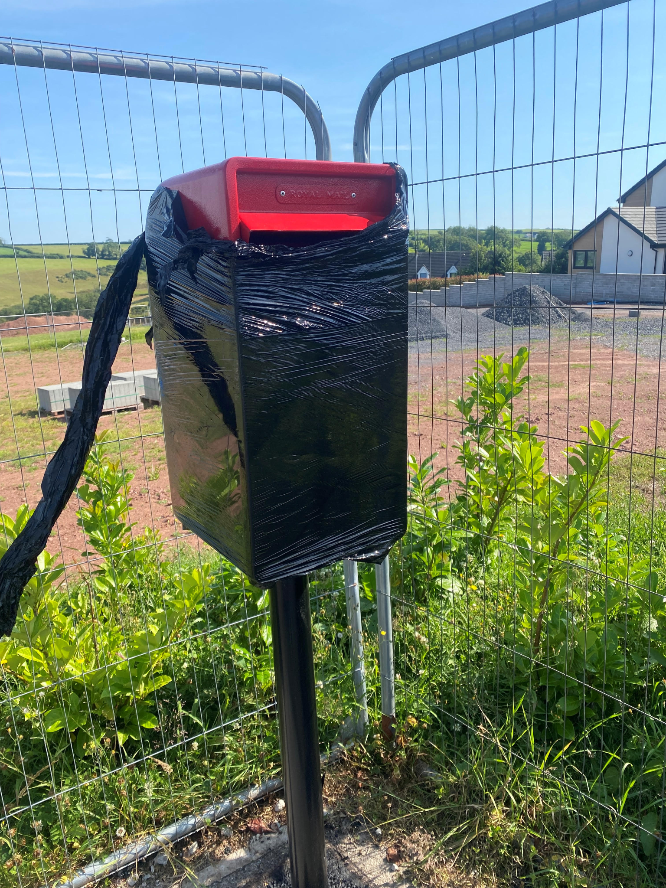
8 | Review of Public Participation Standing Orders (as agreed at the June 2026 meeting)  As covered in agenda item 6.  Cllr discussed updating the Standing Orders around the public participation. See text at Item 6.  Cllr RW proposed an amendment to the Standing Orders to retain the requirement for members of the public to submit requests, questions, comments or other representations to the Clerk in writing before the meeting. Any member of the community making such a representation would then be formally invited to participate in the public participation section of the meeting to present or expand upon their submission.  ACTION: Clerk to revise and bring the standing orders to September to amend / agree in the September meeting.  Proposed RW and seconded DS (voted and all Cllrs in favour)
9 | Community Issues  - Notice Boards: update on condition of Llansteffan and Llanybri notice boards; options and next steps  Cllr TR reviewed the Llanybri notice board. Cllr TR was happy with the current notice board but recommended the wood be varnished following the hot weather. ACTION: Clear up Crew will support.  Cllr TR recommended addressing a potential maintenance / handyman contract for the Community Council (10 hours per week) once again. ACTION: Clerk to add to the September agenda.  Cllr RW reviewed the Llansteffan notice board. Cllr RW informed Cllrs that J. Evans was willing to support the maintenance of the notice board for the cost of materials only £50. LLCC is very grateful to J. Evans for his help with this matter. Cllr RW proposed and Cllr TR seconded.  Cllr RW and TR recommended adding all visitor/tourist information boards owned by the community council onto the agenda to discuss ongoing maintenance. ACTION: Clerk to add to the September agenda.  - Sea pollution: Update on River Towy sewage main; NRW water testing at Llansteffan  Cllr DS to get in-touch with a member of the public who is known to be closely involved with this issue, LLCC wish to support local endeavours to help with the sea pollution issue (as per action log). ACTION: DS to contact said community member.  - Llansteffan Village Green – Street Lighting Grant Application  The Community Council have received confirmation from Arwel Price from Carmarthenshire Community Council (please see below). ACTION: Clerk to chase Arwel for costs.  Thank you for your email.  I am pleased to hear that the Community Council is now in a position to progress a grant application for the replacement lanterns at Llansteffan Village Green.  I will arrange for updated costings to be prepared for the lanterns previously discussed with Councillor Worrell and will forward these to you as soon as possible to support the grant application.  With regard to installation and maintenance, I can confirm that, should the grant application be successful and the replacement lanterns be procured, Carmarthenshire County Council would undertake the installation and continue to provide ongoing maintenance of the lighting on behalf of the Community Council.  For clarity, whilst the County Council would carry out maintenance activities, the street lighting assets would remain the property of Llansteffan and Llanybri Community Council, with ownership and responsibility for asset replacement and renewal remaining with the Community Council.  I trust this provides the assurance required for the funding application, but please let me know if you require any further information or a more formal statement of support.  - Play Park  Cllr RW confirmed unfortunately the member of the public asked for a quote to support the play park maintenance was unable to support. ACTION: Cllr RW will source another local contractor. Cllrs were content for Cllr RW will bring costs / quotes in September.  - Sports Club Lease  No further update from Carmarthenshire County Council. Please see the latest correspondence below. ACTION: Clerk to follow up with Carmarthenshire County Council.  Hi,  We’ve received similar correspondence from the treasure of the sports club Joanne Smith (see attached).  My colleague Emily Hughes will pick this matter up with you and advise accordingly on the options.  Kind Regards  Stephen  Cllr AC discussed an issue brought to him by a member of the public regarding the dilapidated cricket nets and a potentially (not confirmed) rotting poll. This is a long-standing issue and Cllrs agreed that the Sports Club have previously said they would address the issue. ACTION: Clerk to email the Sports Club to highlight the issue and to support the removal nets.
10 | Beach Front and Car Parks  - Cockle Season: update from the joint Community Councils group (Llansteffan, St Ishmael, Laugharne Township) ahead of mid-July season start; compensation / financial support.  Cllrs discussed the extra-ordinary meeting and minutes (enforcement and payments). The minutes are available on the Community Council website or via request from the Clerk.  Cllr TR gave a positive update on the Llanstaffen cockle season. Llanybri beds have been closed following an update from the Welsh Government. The reason for closure: There is evidence that the harvestable surplus has been taken.  The Community Council has been supported financially with a payment for supporting the sustainable management of the cockling. The council have received £6,800 (two separate payments of £3,400). The payments are to compensate the community for the potential disruption that the cockling season brings to the community.  Cllr TR discussed the positive behaviour of the cocklers in Llansteffan. Cllr DS emphasized the importance of the three community councils coming together to support the local communities.  Cllr AC discussed that the management of the cocklers this year has been overall positive (especially compared to previous years). Cllr AC explained he has seen / had reports from members of the public regarding cockling at midnight and 4am. This goes against the cockling rules set out by the Welsh Government in the Fisheries Permit. This suggests continued illegal poaching. Cllr RW recommended advertising the cockling rules in Llansteffan on social media (Cllrs agreed).  Cllr TR recommended public consultation on the use of money received. ACTION: Cllr RW to draw up a public notice of consultation for review and to share on social media.  - Anti-social behaviour at Llansteffan beach front: follow-up with local schools.  Cllrs RW has followed up with local schools. The local schools have expressed this is not the responsibility of the schools directly but are happy to support through continued Welsh Bacc activity such as the school litter picks. Cllr RW discussed the local schools supporting litter picking on Llansteffan beach and how it was a great success / excellent community engagement.
11 | Highways / Traffic  - Road landslide  Cllr TR to follow up with Cllr IR regarding providing photos to support within the action log.
12 | Planning  - Any planning applications received for consideration:  PL/10938: Proposed build of detached 3-bedroom house on and at High Street, Llansteffan and demolition of existing dilapidated old church hall - Old Church Hall, High Street, Llansteffan, Carmarthen.  The Community Council was unable to get an extension past 16.07.2026 to make a comment. The response to an extension is below.  Thank you for your comments in relation to this application.  This application seeks Conservation Area Consent (CAC) following the approval of a Variation of Condition application (PL/10318) on 5 June 2026. The purpose of the current application is to regularise the associated Conservation Area Consent to reflect the amendments approved under PL/10318. The principle of the development has already been established through the approval of previous applications, namely PL/02032 (Full Planning Permission) and PL/02075 (Demolition in a Conservation Area). Subsequent design amendments were approved under application PL/10318. This CAC application does not seek to revisit the principle of demolition but instead ensures that the amended plans approved under PL/10318 are appropriately reflected within the Conservation Area Consent.  Whilst your comments will be duly noted and taken into consideration, it should be recognised that the principle of demolishing the building has already been authorised through application PL/02075. The consultation period for this CAC application commenced on the date the site notice was erected, namely 25 June 2026, and expires on 16 July 2026. It is intended that the application will be determined on, or shortly after, this date. Accordingly, if you wish your comments to be taken into account as part of the formal assessment of the application, you are advised to submit them before 16 July 2026 to ensure they can be fully considered by the Local Planning Authority.  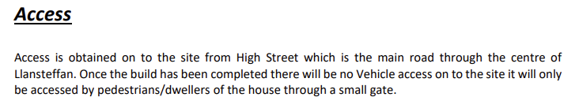  Cllr AC raised concerns regarding parking arrangements, noting that the property does not benefit from dedicated parking access. It was noted that this matter had also been discussed when the original planning application was considered by the Community Council several years ago. At that time, the issue was highlighted by the Community Council; however, it appeared that the planning authority did not attach significant weight to this aspect when determining the application.  - Planning application response approach: Draft professional template (Cllr AC)  Cllr AC discussed the wording being used around planning applications. Cllr AC has contacted a Community Council for sharing best practice on existing documents being used to support planning applications. Cllr AC to follow up and discuss further in the September agenda. ACTION: Clerk to place on Sept agenda.
13 | Finance / Governance  - 2026/27 Payments and Receipts  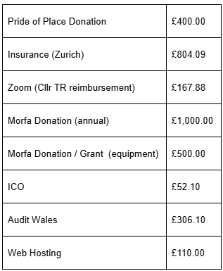  - Telephone kiosk purchase (BT, £1): approval of signed contract  Discussed and recorded under agenda item 5.  - 2025/26 Annual Report: publication on community council website  Annual Report updated by the Clerk. Cllr RW proposed adding the 25/26 annual report onto the website and sharing with Audit Wales. Seconded by Cllr DD. All agreed (Cllr AC abstained as he is relatively new to LLCC and was not present for 25/26)). ACTION: Clerk to add to the website  - Facebook administration  Cllr RW discussed the use of Facebook and the required administration. Cllr RW would be happy to support and oversee the use of Facebook for the Community Council.  Cllr AC discussed the wider use of social media for the Community Council.  Cllr TR recommended training for social media (Cllr TR knows a local trainer). The cost of the training is £350 (inclusive of VAT). ACTION: Clerk to add training request and cost for Cllr RW to the September agenda. Cllr TR to liaise with the trainer.  - Grant policy review (review of grant application from Vaughan Howells)  Cllr RW discussed the current policy and requirements for bank accounts / bank statements. Cllrs agreed that bank accounts of established community organisations can be used for new groups or projects (as per the pride of place).  Cllrs AC discussed the grant application circle throughout the financial year. Cllr TR proposed 2 windows April and October each financial year for public application. To coincide with the summer and Christmas periods.  Cllrs discussed Vaughan Howells grant application on behalf of the Fiesta Committee. Cllr RW proposed to accept the grant application. Seconded by Cllr TR. All cllrs voted and agreed. ACTION: Clerk to pay grant.
14 | Correspondence of Note  Gwynt Glas Offshore Wind Farm  Cllr RW shared the wind farm plans with Cllrs. No further comments. No requirement to respond to Gwyant Glas. Cllr DS recommended asking for a grant for the Community Council from Gwynt Glas Offshore Wind Farm.  Clear Up Crew Shed  Cllr RW declared an interest and wanted to leave the room. Cllr AC asked her to stay to hear his comments. She sat in the public gallery accordingly and made no comment to the discussion. Cllrs discussed the latest emails from AG. Cllrs were content with their original decision in relation to the siting of the shed and will await further correspondence from AG or their solicitor.  Nant Jac Path / Vandalism of the bridge crossing Nant Jack stream  Cllrs RW discussed the vandalism of the bridge. Cllr RW have contacted Carmarthenshire Community Council. ACTION: Ongoing with Cllr RW to liaise with Carmarthenshire County Council.  Cllrs discussed the overgrown Nant Jac Path. ACTION: Clear up Crew will do it one more time on Sunday and Cllr DD to source contractor to clear path going forward.  New batteries (defibrillators)  For information. Cllrs are aware new batteries have been installed in the defibrillators.  Dealing with correspondence  Cllrs discussed the issue. Cllr TR recommended anonymising members of public names in the minutes. The Clerk agreed and will amend minutes accordingly.  County Cllr update  No update received for July meeting.
15 | Matters for information  Cllr TR discussed: Questionnaire from Democracy and Boundary Commission Cymru and Code of Conduct Training.  Cllr TR asked whether the maintenance issue at Llanybri park had been remedied (bolts on the climbing frame and seat for rocky dolphin). ACTION: Cllr DS to follow up on the maintenance issues.  Cllr DD asked for an update on the TRJ Community Benefit as it was issued for applications over 12 months ago. No update to date from the County Council. ACTION: Clerk to write directly to TRJ for an update.  Cllr DD requested clarification on behalf of a member of the community how the Community Council's £400 donation to the Pride Committee had been spent. Cllr RW, in their capacity as Treasurer of both the Village Hall and the Pride Committee, confirmed that a detailed spreadsheet would be provided to the Clerk and Cllrs showing how the £400 donation had been allocated. Cllr RW also agreed to provide an explanation of the purpose of the separate fundraising income received by the Pride Committee.  Cllr RW have agreed to Clear up Crew will support with litter picks prior and post Fiesta.

Date of the next meeting: 21.09.2026

